08/04/2024 Monday Ramadan.

Lesson 136

Introducing Forking

<https://github.com/gabrielecirulli/2048>

<https://github.com/Colt/2048>

Now I can clone it down to my machine. Can add collaborator etc

I changed some css

The changes is done locally but I don’t have the permission to push to the original but I can push to my folk

Lesson 138

The Fork & Clone Workflow

This refers back to the original that I forked. The upstream mean even if I can upload I want to get the changes on my machine.

I can make a pull request and asked for my changes to be made in.

This is to enable people that does not have permission to work on the project and make a pull request later.

This is the cycle

Lesson 139

Ramadan last day 09/04/2024

Fork & Clone Workflow Demonstration

Use don account and create new repo with no collaborator

Go back to dev now.

I need to fork this repo I will fork it on dev. Dev looked for don’s account look for the repo and fork it

I want to setup 2nd remote.

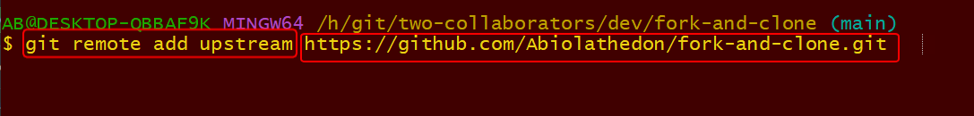

I will switch back to don below

This happened on don the dev does not have this changes

They are no more attached. I can still get the changes locally as I have the remote.

Now I have work on a branch and I want to push it to the original. I don’t have the permission to that to push to upstream but I have permission to push to my fork-and-clone

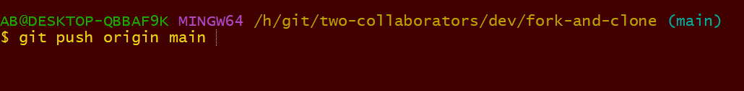

This is the dev page

Dev fork the repo, make changes to the repo, request for pull request and got merge in